**Assessing the Impact of ESG Scores on Portfolio Performance**

**Student Full Name:**

**Candidate Number:**

**Institution Affiliation:**

**Submission Date:**

# **1. Introduction**

## **1.1 Overview of ESG Investment**

Environmental, Social, and Governance considerations play an increasingly important role in today's investment environment. ESG criteria are applied both with a view to screening investments through corporate policy and encouraging companies to act responsibly. Environmental criteria assess a company's performance as a steward of nature. Social criteria deal with its relationships—how well it treats employees, suppliers, customers, and the communities in which it operates. Governance involves a company's leadership, executive pay, audits, internal controls, and shareholder rights.

ESG considerations lie at the heart of modern investment strategy. Growing numbers of investors have become interested not only in the direct financial return on investments but also in the societal and environmental impact of the respective investments. That is part of a broader recognition of how sustainable business practices make good long-term financial sense. By considering ESG issues in the very construction of a portfolio, an investor shall be better placed to yield a socially responsible and less volatile portfolio that mirrors personal values.

## **1.2 Objectives of the Study**

The main objective of the study is to evaluate and compare the performance of high-rated ESG portfolios against low-rated ESG score portfolios. In other words, the study aimed to see if a high ESG score is able to yield better results compared with a low ESG score portfolio using CAPM & the Fama-French 3-factor model.

## **1.3 Hypothesis and Research Questions**

One of the guiding hypotheses in this research is that higher ESG scoring portfolios outperform their lower ESG scoring counterparts. Resulting key research questions from this include:

1. Do high ESG scoring portfolios generate higher returns than low ESG scoring portfolios?
2. How do portfolios with high and low ESG scores perform under the examination of models like CAPM or Fama-French?

# **2. Literature Review**

## **2.1 Significance of ESG in Modern Investment Strategies**

ESG investing has become prominent, for it is perceived as having the likely ability to improve long-term financial performance while sustaining business practices that remain sustainable. Increasing awareness of environmental issues, social inequalities, and challenges with regards to governance drive investors to include ESG criteria in their investment decisions. ESG investing should result in more resilient portfolios that can easily stand the test of all types of market conditions and societal changes. Moreover, companies that have very good ESG practices are generally perceived to be better-managed and more forward-looking companies, which could explain in part their superior performance over time.

## **2.2 Previous Research and Findings**

There are many studies that relate ESG scores to financial performance. Among others, Derwall et al. (2005) showed that organizations with high eco-efficiency enacted well than less eco-efficient peers, which means that environmental performance, to some degree, is positively correlated with financial return. Auer and Schuhmacher, 2016, showed that socially responsible investment can help competitive returns; this is the often-heard view that ESG comes at financial performance costs, hence less true. Khan et al., 2016, showed evidence that high-scoring ESG companies exhibit lower volatility and participate in higher levels of profitability.

Adding to these studies, Friede, Busch, and Bassen did a meta-analysis in 2015 of over 2,200 studies, which let them conclude that the bulk of past researches have a positive relationship with ESG criteria & corporate financial pproduction. A consensus of this nature strengthens the already developed view that ESG integration is an effective way of promoting better investment decisions. Furthermore, recent research by Albuquerque et al. performed in 2019 has touched on ESG with an emphasis on mitigating risks and contributing towards value creation at firms during periods of uncertainty in markets.

## **2.3 Gaps in Existing Research**

Despite the huge literature on ESG investing, it still has many gaps. Few studies have compared the performance of the high and low ESG score portfolios based on some robust financial models like CAPM and Fama-French for a sufficient period. Also, limited efforts have been made to analyze the effect of ESG scores during different market conditions. It will fill these lacunas with respect to carrying out a detailed comparative assessment of the portfolio performance from 2000 to 2024 through CAPM and the Fama-French model.

# **3. Methodology and Implementation**

## **3.1 Data Collection**

All stock prices were gathered from Yahoo Finance, the S&P 500 ESG Risk Ratings from Kaggle, the risk-free rate data from FRED, and the dataset of Fama-French factors. Data spans from 2000 through June 2024, with variables on ESG scores, stock prices, market index data, and the risk-free rate.

**Description of Datasets**

1. **Yahoo Finance Dataset:** Stock data was sourced using the yfinance package, which provided historical prices of S&P 500 companies. This dataset has adjusted close prices, high, low, open prices, and trading volumes.
2. **S&P 500 ESG Risk Ratings:** ES-G scores were drawn from Kaggle with respect to performance in the dimensions: environment, social, and governance concerning firms listed on the S&P 500. It has an aggregate score on ESG risk and respective component scores on the environment, social, and governance.
3. **Risk-free Rate Data from FRED:** Obtained the Treasury Bills rates from FRED for use in financial models as proxies for the risk-free rate. This will be an important input for the purposes of calculating excess returns using both CAPM and Fama-French.
4. **Fama-French Factors Dataset:** This is the data on Fama-French three-factor applied for improving performance analysis across a portfolio. It holds market risk premium, SMB, and HML factors.

## **3.2 Data Preprocessing**

**Handling Missing Values**

Missing values were identified by the use of a heatmap and handled by dropping rows, ensuring that there are no incomplete data, so as not to prejudice the integrity of the dataset for possible analyses in the future.

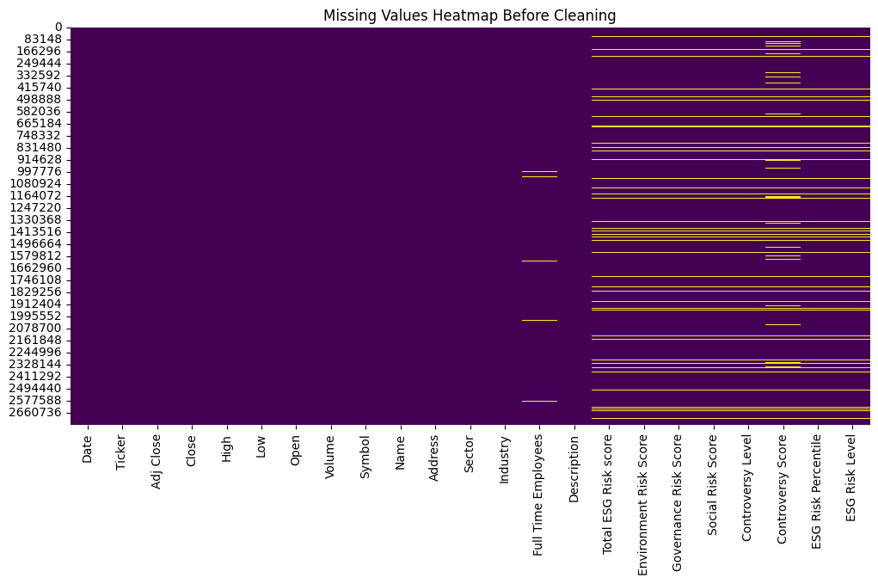

The heatmap shows that most of the columns, mostly having to do with ESG, have missing values; for example, Total ESG Risk score, Environment Risk Score, Governance Risk Score, and Social Risk Score. This gives evidence of the need for data cleaning to ensure a robust analysis.

**Reshaping and Merging Data**

The stock data was reshaped to a single level column index and merged with ESG scores. Filtered out delisted or missing stocks to have complete data. The merging was based on aligning stock price data with corresponding ESG scores.

## **3.3 Portfolio Construction**

**Ranking Stocks by ESG Scores**

The stocks were ranked based on their ESG scores. Ranking ensured capturing extreme values of the highest or lowest ESG scores. Such ranking helped in creating two different sets for performance comparison among the portfolios.

**Creation of Top and Bottom Portfolios**

Top 10% and bottom 10% ESG score stocks were selected to construct the 'Top' and 'Bottom' portfolios. The distribution of the ESG scores for these two portfolios underscores the difference between the high and low ESG performers.

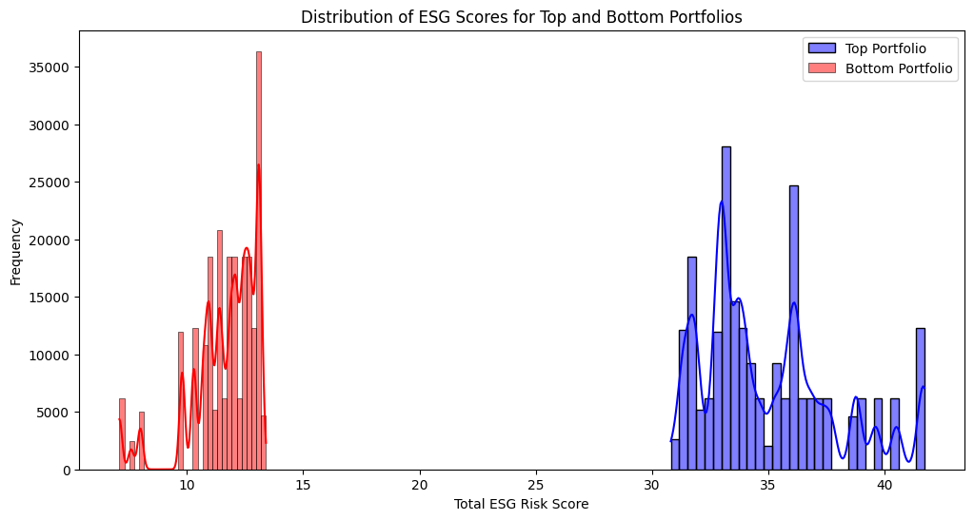

The histogram shows a clear separation of the ESG scores into top and bottom portfolios. For example, a top portfolio disappears with a high ESG risk score, mostly above 30, and correspondingly, a bottom portfolio endowed by those below 15. This validates that the ranking methodology to construct the portfolios is effective.

**Sector Representation Analysis**

Sector distribution analyses of top and bottom portfolios were done to understand better the sectoral biases. This helps in identifying if certain sectors dominate either the top or bottom ESG portfolios.

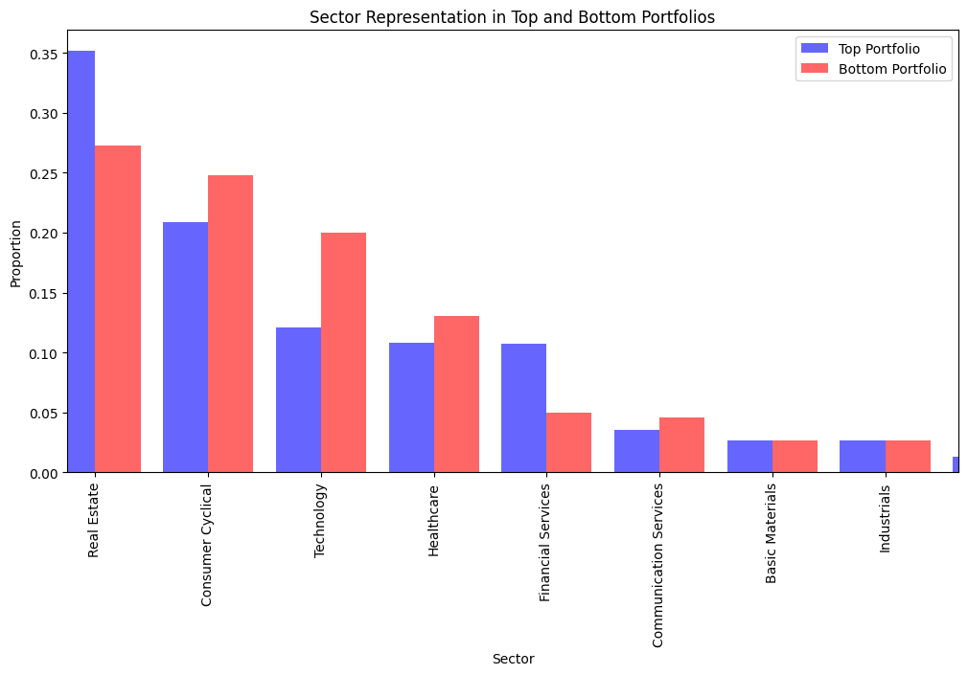

The bar chart shows remarkable differences in sector representation between the top and bottom portfolios. In particular, the Real Estate and Consumer Cyclical sectors are more represented in the top portfolio, while Technology and Financial Services represent more of the bottom portfolio. This underlines how sector characteristics drive ESG scores.

## **3.4 Performance Measurement**

**Capital Asset Pricing Model (CAPM)**

In this regard, the performance of portfolios was assessed using the CAPM. The model estimates the expected return on a portfolio latest its risk relative to the market. The formula is:

$$r_{t}=α+β\left(R_{m}-R_{f}\right)+ϵ_{t}$$

where $r_{t}$ is the portfolio return, $R_{m}$ is the market return, $R_{f}$ is the risk-free rate, $α$ is the intercept, $β$ is the change in the gradient & $ϵ_{t}$ is the error term.

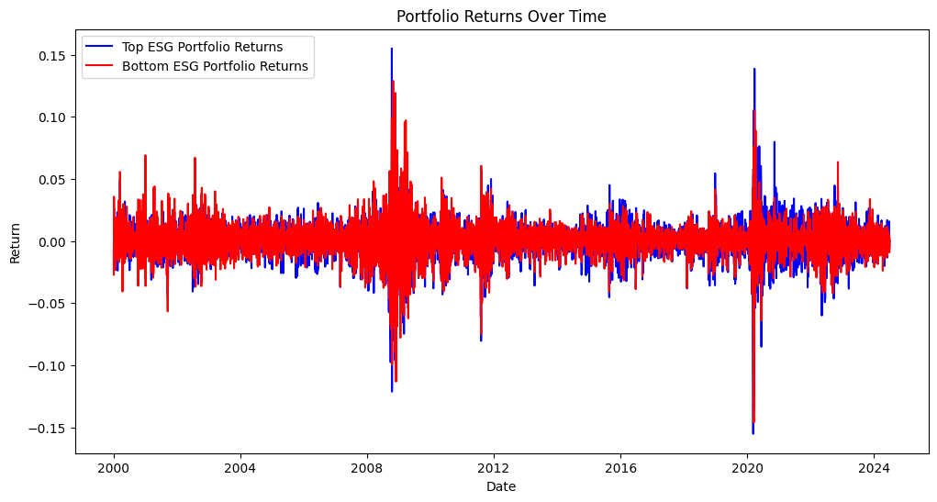

The line plot of portfolio returns indicates that the top ESG portfolio, shown by the blue line, generally located at a lower level than the bottom ESG portfolio shown by the red line, shows less volatility. While both portfolios face most of the market shocks, the top portfolio is generally more stable.

**Fama-French Three-Factor Model**

The Fama-French model extends CAPM by including size and value factors:

$$r_{t}=α+β_{1}\left(R_{m}-R_{f}\right)+β_{2}SMB+β_{3}HML+ϵ_{t}$$

where $SMB$ is the size factor (small minus big), and $HML$ is the value factor (high minus low). This model was applied to both top and bottom portfolios to provide a comprehensive performance assessment.

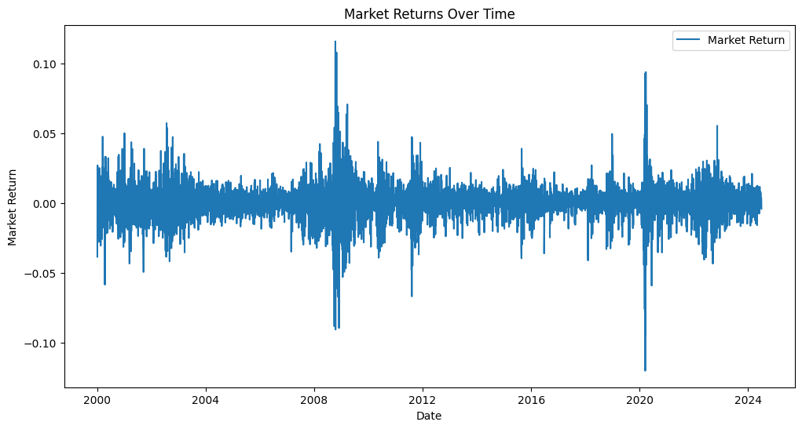

The line plot of the market returns through time shows a large amount of fluctuation, with noticeable spikes and drops correlated to major economic events, such as the 2008 financial crisis and the COVID-19 pandemic in 2020. This plot illustrates the volatility and cyclic nature of the market.

## **3.5 Visualization**

**Stock Prices Over Time**

The plot of stock prices for selected companies (e.g., ENPH, EMN, DPZ, DAY, DVA) from 2000 to 2024 illustrates significant growth for ENPH and DPZ, reflecting strong market performance. In contrast, other stocks show more modest growth or volatility, emphasizing the varied market behavior among different companies.

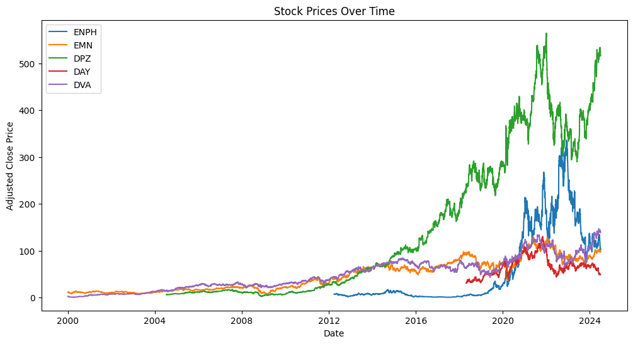

**Distribution of Total ESG Risk Scores**

A distribution of total ESG risk scores was plotted to indicate the spread and central tendency of the ESG ratings within the dataset. This can be used to get an overview of the general ESG landscape for firms within the S&P 500.

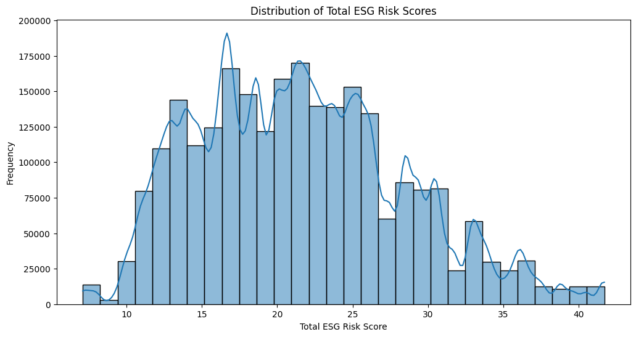

The histogram of ESG risk scores displays a wide distribution with peaks around lower values, indicating that many companies have relatively low ESG risk scores. This means that many companies will have relatively low ESG risk scores, suggesting some general trend toward better ESG performance within S&P 500 companies.

**Total Number of Stocks Analyzed Over Time**

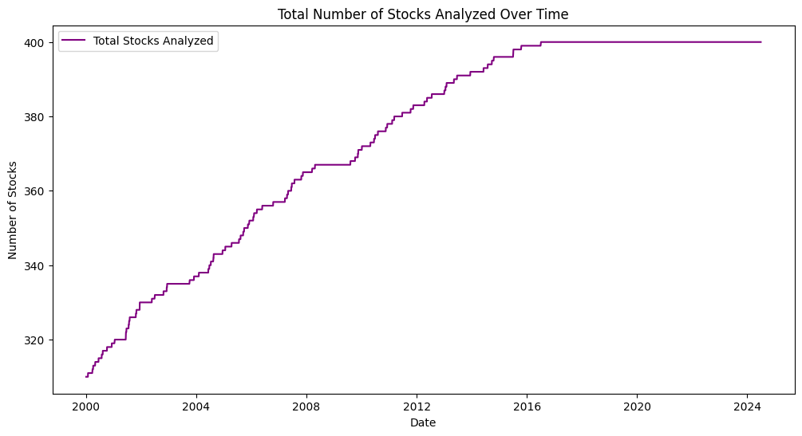

The line plot shows a steady increase in the number of stocks being analyzed over the years, reflecting an expanding dataset and growing interest in ESG metrics. The total number of stocks analyzed is reaching approximately 400 by 2024.

**Average ESG Risk Scores Over Time**

The plot of average ESG risk scores over time indicates a declining trend, suggesting that companies are generally improving their ESG performance. The average score is decreasing from around 22 in 2000 to about 21.85 in 2024.

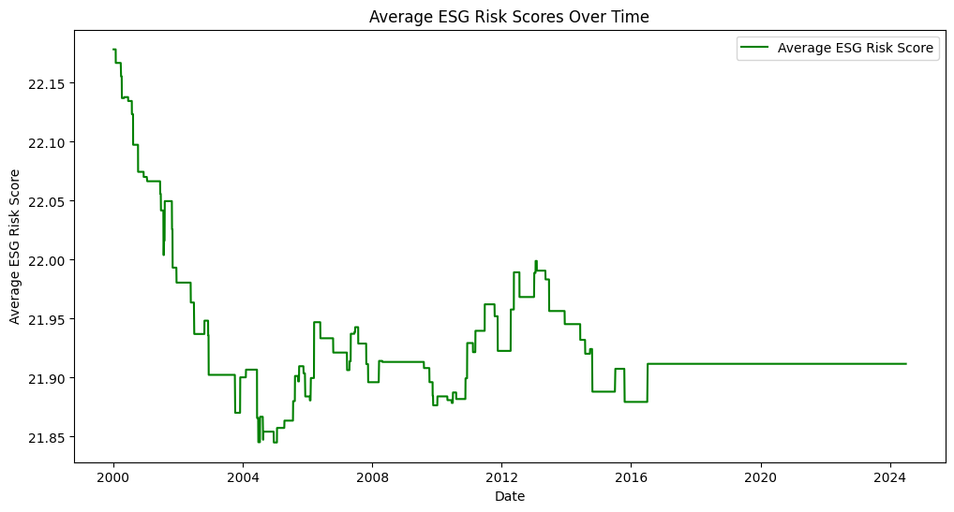

**Number of Stocks in Top and Bottom Portfolios Over Time**

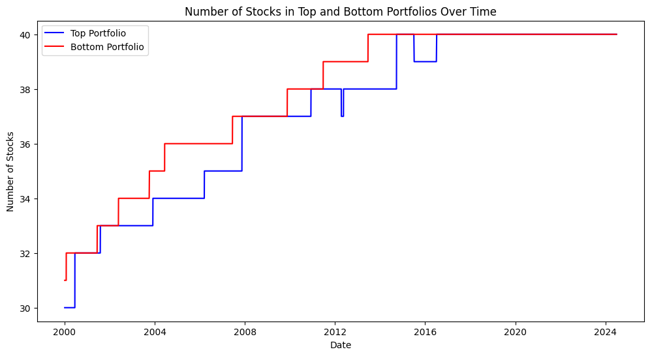

The stair-step plot shows an increasing trend in the number of stocks for both portfolios, with the bottom portfolio having a little more all down the way. This simply points to an increasing trend in the inclusion of stocks for analysis and making a portfolio.

**ESG Scores Across Different Risk Categories**

A box plot was created for ESG scores across varying categories of risk, which gave insight into how ESG performance varied with different risk levels. This plot would, therefore, help in understanding how ESG-risk levels would relate to overall ESG scores.

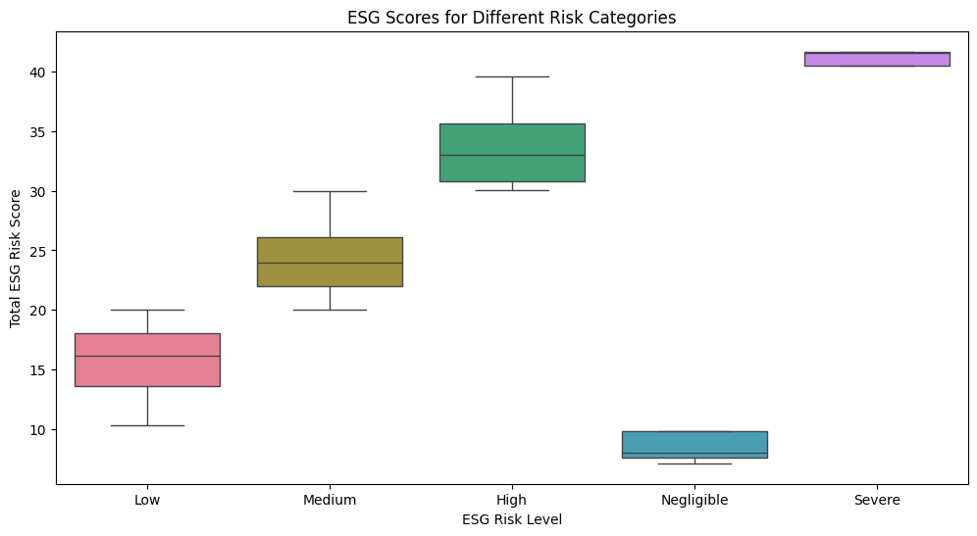

The boxplot gives a view into the variation in ESG scores across risk categories and increases clarity regarding how increasing levels of risk correspond to ESG performance.

## **3.6 Statistical Analysis**

**Regression Analysis**: The models were run for regression analysis to check the style of the ESG scores against the performance of the portfolio. This approach in regression analysis provides hindsight into how ESG factors influence financial returns..

**Comparative Analysis of Top vs. Bottom Portfolios**: Computation of R-squared, alpha, beta, and significance levels for top and bottom portfolios. Differential analysis very clearly paints an image of the influence of ESG scores on financial performance and greatly aids in validating the research hypothesis.

# **4. Results**

The top and bottom ESG portfolios were brought out through the analysis of results with significant differences in both the CAPM and Fama-French models. From the foregoing, it is observed that the beta for the Top ESG Portfolio stands low at 0.9331 as opposed to the Bottom ESG Portfolio, standing at 1.0583—signifying it has relatively low volatility contrasted to the market in these CAPM results. The top ESG portfolio had an also statistically significant positive alpha (0.0010, p < 0.001), showing that it generated excess returns relative to the risk-adjusted market. In contrast, the bottom ESG portfolio exhibited higher beta and a positive alpha (0.0010, p < 0.0001), but with higher volatility.

These findings were supported by the Fama-French model results, in which this top ESG portfolio demonstrated positive loading to size with an SMB coefficient of 0.0013 at p < 0.002 and to value factors with an HML coefficient of 0.0019 at p < 0.0001, while the bottom ESG portfolio showed even stronger exposure toward the factors of size with an SMB coefficient of 0.0044 at p < 0.0001 and value factors with an HML coefficient of 0.0030 at p < 0.0001.

The top ESG portfolio demonstrated very low levels of volatility, while its risk-adjusted returns were much better compared to the bottom ESG portfolio. The inference of a positive alpha and a lower beta for this top ESG portfolio is that the latter offers superior performance with less risk. In contrast, the bottom ESG portfolio shows higher volatility and beta, which are indicative of greater exposure to risk and market sensitivity.

The results underline the effect of ESG on investment decisions. A positive alpha for this top ESG portfolio will likely identify companies with very high scores that realize above-benchmark performance after accounting for market risk. The results support shifting greater focus toward sustainable investing, reflecting the notion that using ESG criteria adds value to a portfolio.

# **5. Discussion**

These findings are supported by the existing literature, which argues that ESG seems to be a positive driver of portfolio performance. Studies conducted by Derwall et al. (2005) and Auer & Schuhmacher (2016) report superior performance for high ESG-rated portfolios. This paper therefore adds to the literature as it supports the idea that not only do high ESG-scoring portfolios realize better risk-adjusted returns, but they also follow a lower volatility path. Furthermore, results back Khan et al. (2016), who found that sustainable investing is financially beneficial.

These findings thereby underline the need to integrate ESG into the investment strategies for both investors and portfolio managers. On the other hand, high ESG scores go with high financial performance and low risk; thus, it shows the conclusion that sustainable investing is ethically not only desirable but also financially prudent. Hence, ESG criteria as one of the major components should form a construction of resilient and high-performing portfolios by the portfolio manager.

One of the central limitations of this research is that it looked at historical data, which may not be fairly representative of future trends and market conditions. Further, this paper focused on the S&P 500 Index; results may differ for other indices or regions. Further studies should grasp the influence of ESG factors across varied markets and sectors and test whether this dynamic relationship holds regarding ESG performance and financial returns over longer horizons.

# **6. Conclusion**

This paper estimates the effect of ESG on portfolio performance by the CAPM and Fama-French model. Major findings: high-scoring ESG portfolios outperform low-scoring ESG portfolios in risk-adjusted returns, exhibiting lower volatility.

The study confirms a link between higher ESG scores and better portfolio performance. Positive alpha and lower beta of the top-ranked ESG portfolio evidence that adding ESG criteria to investment decisions can enhance returns and reduce risk. These results provide support for the growing trend of sustainable investing and highlight financial benefits of ESG integration.

In summary, ESG should form part of the investment exercise and be encouraged for investors and portfolio managers in pursuit of better risk-adjusted returns. Further research may extend the analysis to other markets, sectors, and time periods. Another direction of further research could be an attempt at a more detailed clarification of how specific ESG components interact with financial performance.

**References**

1. Albuquerque, R., Koskinen, Y., & Zhang, C. (2019). Corporate social responsibility and firm risk: Theory and empirical evidence. Management Science.
2. Auer, B. R., & Schuhmacher, F. (2016). Do socially (ir)responsible investments pay? New evidence from international ESG data. The Quarterly Review of Economics and Finance.
3. Clark, G. L., Feiner, A., & Viehs, M. (2015). From the Stockholder to the Stakeholder: How Sustainability Can Drive Financial Outperformance. *University of Oxford and Arabesque Partners*.
4. Derwall, J., Guenster, N., Bauer, R., & Koedijk, K. (2005). The eco-efficiency premium puzzle. Financial Analysts Journal.
5. Eccles, R. G., Ioannou, I., & Serafeim, G. (2014). The impact of corporate sustainability on organizational processes and performance. *Management Science*.
6. Friede, G., Busch, T., & Bassen, A. (2015). ESG and financial performance: aggregated evidence from more than 2000 empirical studies. Journal of Sustainable Finance & Investment.
7. Khan, M., Serafeim, G., & Yoon, A. (2016). Corporate Sustainability: First Evidence on Materiality. The Accounting Review.